- Create a table listing 3 types of printers, 2 types of scanners, and 2 types of webcams, and for each, write one real-life use case (for example: 'Inkjet printer – printing college assignments')
---------------------------------------------
Real-World Devices That Use SMPS and UPS
Introduction
Electrical and electronic devices require a reliable power supply to operate safely and efficiently. Two common types of power supply systems are Switched Mode Power Supply (SMPS) and Uninterruptible Power Supply (UPS).
- SMPS (Switched Mode Power Supply) is an electronic power supply that converts high-voltage AC (Alternating Current) from a wall socket into the low-voltage DC (Direct Current) required by electronic devices. It is highly efficient, lightweight, generates less heat, and is used in most modern electronic equipment.
- UPS (Uninterruptible Power Supply) is a backup power system that provides electricity from a battery when the main power supply fails. It protects devices from sudden power outages, voltage fluctuations, and data loss.
---------------------------------------------------------------------
Devices That Use SMPS
1. Desktop Computer (CPU)
Power Supply Type: SMPS
A desktop computer contains an SMPS inside the CPU cabinet. The SMPS converts the 230V AC power from the electrical outlet into different DC voltages such as 3.3V, 5V, and 12V required by the motherboard, processor, hard drive, graphics card, cooling fans, and other components.
Why it needs SMPS:
- Converts high-voltage AC into multiple regulated DC outputs.
- Provides stable power to sensitive computer components.
- Has high efficiency (around 80–90%), reducing electricity waste.
- Produces less heat compared to traditional power supplies.
- Protects hardware from voltage fluctuations and overload.
---------------------------------------------------------------------
2. LED Television
Power Supply Type: SMPS
Modern LED televisions use an SMPS to convert household AC power into low-voltage DC required by the display panel, processor, speakers, and other internal circuits.
Why it needs SMPS:
- Supplies stable DC voltage for smooth picture and sound.
- Consumes less electricity than older power supplies.
- Generates less heat, increasing the television's lifespan.
- Makes the TV lighter and more compact.
- Improves overall energy efficiency.
---------------------------------------------------------------------
3. Wi-Fi Router
Power Supply Type: SMPS
A Wi-Fi router receives electricity through a small adapter that contains an SMPS. The adapter converts 230V AC into 9V or 12V DC, depending on the router model.
Why it needs SMPS:
- Converts mains electricity into the low voltage required by the router.
- Ensures stable internet connectivity.
- Prevents damage caused by voltage variations.
- Operates efficiently with minimal power loss.
- Allows the router to run continuously with low heat generation.
---------------------------------------------------------------------
Devices That Use UPS
1. Desktop Computer with UPS
Power Supply Type: UPS
Many homes, colleges, and offices connect desktop computers to a UPS. During a power failure, the UPS immediately supplies battery power, allowing users to save their work and safely shut down the computer.
Why it needs UPS:
- Prevents sudden shutdown during power cuts.
- Protects important files from being lost.
- Prevents damage to computer hardware.
- Protects against voltage fluctuations and power surges.
- Gives users enough time to save their work before shutting down.
---------------------------------------------------------------------
2. CCTV Security System
Power Supply Type: UPS
CCTV cameras and Digital Video Recorders (DVRs) often use a UPS to keep recording during power failures. Continuous surveillance is important for security in homes, colleges, banks, hospitals, and offices.
Why it needs UPS:
- Keeps cameras operating during power outages.
- Ensures continuous recording for security.
- Prevents gaps in surveillance footage.
- Protects DVR and camera equipment from voltage problems.
- Maintains security even during emergencies.
---------------------------------------------------------------------
Difference Between SMPS and UPS
Feature | SMPS | UPS
Full Form | Switched Mode Power Supply | Uninterruptible Power  Supply
Main Function | Converts AC power into regulated DC power | Provides backup power during electricity failure
Uses Battery | No | Yes
Power Backup | No | Yes
Main Purpose | Efficient power conversion | Continuous power supply during outages
Common Applications | Computers, TVs, routers, monitors, print | Computers, CCTV systems, servers, medical equipment
------------------------------------------------------------
- Draw a labeled diagram showing how a typical home printer connects to a laptop or PC, including the connection interface used (USB, Wi-Fi, or Bluetooth).

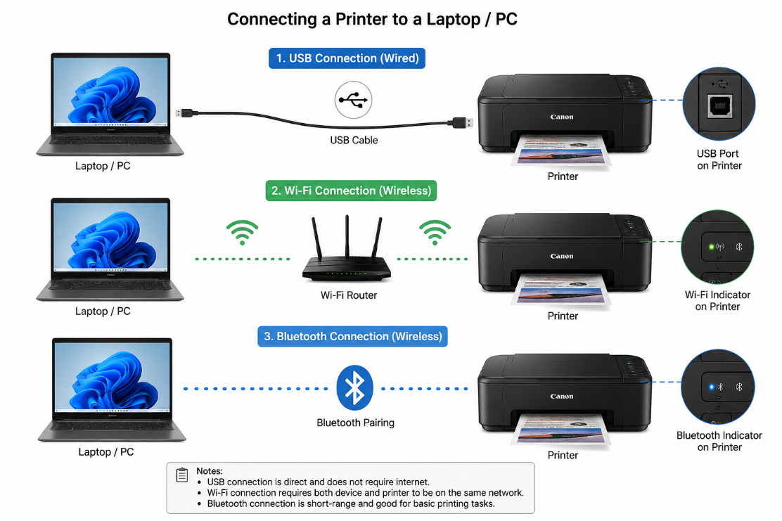
------------------------------------------------------------
- List three different connection interfaces (such as USB, Wi-Fi, Bluetooth) used by peripherals like printers, scanners, and webcams, and for each, name one advantage and one disadvantage. Think about speed, convenience, and compatibility
Peripherals like printers, document scanners, and webcams rely on distinct connection interfaces to transfer data to and from host devices like desktop computers, laptops, tablets, and smartphones. The choice of interface directly affects data transfer speed, signal stability, physical mobility, and ease of setup.
Here is an in-depth breakdown of three primary connection interfaces—USB, Wi-Fi, and Bluetooth—along with their respective advantages and disadvantages across speed, convenience, and compatibility.
1. USB (Universal Serial Bus)
USB is the standard wired interface for desktop computing peripherals. Over the years, it has evolved from older standards like USB 2.0 to modern high-speed USB 3.x standards and physical connectors like USB-C.
Performance & Characteristics
- Speed: Depending on the generation (e.g., USB 2.0 at up to 480 Mbps vs. USB 3.2 Gen 2 at up to 10 Gbps), USB handles high-density data streams with ease. This makes it the standard choice for uncompressed 4K webcam video feeds and high-DPI color document scanners.
- Convenience: USB provides plug-and-play simplicity. Most modern operating systems immediately recognize connected peripherals without requiring complex network setup. USB cables can also supply electric power (Power Delivery/Bus Power) directly to smaller peripherals like webcams or mobile scanners, eliminating the need for a separate wall outlet.
- Compatibility: Broadly compatible across Windows, macOS, Linux, and ChromeOS. However, newer laptops often feature only USB-C ports, which may require adapters or dongles if using older USB-A cables.
Trade-Offs
- Key Advantage (Speed & Low Latency): USB delivers consistent, uninterrupted high-bandwidth data transfers with virtually zero latency or signal interference. Because it relies on a physical copper connection, there are no wireless drops or buffer lags during high-resolution video streaming or large print jobs.
- Key Disadvantage (Physical Range & Cable Management): USB is restricted by physical distance. Standard passive USB cables generally top out around 3 to 5 meters (10 to 16 feet) before signal degradation occurs. Devices must remain tethered close to the host computer, which limits peripheral placement and adds cable clutter to desk space.
2. Wi-Fi (Wireless Local Area Network)
Wi-Fi uses radio frequency signals (typically 2.4 GHz, 5 GHz, or 6 GHz bands) to connect peripherals to a Local Area Network (LAN) through a central wireless router or access point.
Performance & Characteristics
- Speed: Modern Wi-Fi standards (Wi-Fi 5, Wi-Fi 6, and Wi-Fi 7) offer high bandwidth ranging from hundreds of megabits per second to multiple gigabits per second. This speed easily accommodates large PDF document scans, high-volume batch printing, and HD video streams.
- Convenience: Wi-Fi frees peripherals from physical cables, allowing them to be placed anywhere within range of the router (such as a shared hallway printer or a closet scanner). Once connected to the network, the peripheral can be accessed simultaneously by any authorized laptop, desktop, tablet, or smartphone on that same network.
- Compatibility: Wi-Fi connectivity is supported across almost all modern consumer operating systems and mobile devices. Modern print and scan protocols (like Apple AirPrint or Mopria Print Service) make printing over Wi-Fi simple without requiring manual driver installations.
Trade-Offs
- Key Advantage (Multi-User Network Accessibility): A single Wi-Fi peripheral can serve an entire household or office space. Multiple users can send print jobs, initiate remote scans, or manage peripheral settings from different rooms without needing physical access to the host computer.
- Key Disadvantage (Network Dependence & Interference): Reliability is tied entirely to network health. Signal degradation caused by physical walls, router congestion, IP address conflicts, or internet service outages can cause print jobs to fail mid-way, cause webcams to freeze, or render peripherals offline without warning.
3. Bluetooth (Short-Range Personal Area Network)
Bluetooth is a low-power, short-range wireless standard designed for direct device-to-device communication within a Personal Area Network (PAN), typically spanning up to 10 meters (30 feet).
Performance & Characteristics
- Speed: Bluetooth standards prioritize low energy consumption over raw speed. Data transfer rates are significantly lower than USB or Wi-Fi (typically ranging between 1 Mbps and 3 Mbps for standard Bluetooth Classic / EDR). While sufficient for text documents or small receipt printing, it struggles with large files.
- Convenience: Bluetooth requires no router, internet connection, or external cables. Paring is done directly between the host device and the peripheral. This makes it the primary connection choice for compact, battery-powered peripherals like portable photo printers, handheld barcode scanners, or mobile receipt printers used in retail.
- Compatibility: Nearly every smartphone, tablet, laptop, and modern desktop features built-in Bluetooth hardware, allowing quick pairing across iOS, Android, Windows, and macOS without additional hardware.
Trade-Offs
- Key Advantage (Portability & Direct Pairing): Bluetooth allows peripherals to function in field environments without access to a Wi-Fi network or power outlet. You can print receipts, shipping labels, or photos directly from a mobile phone anywhere.
- Key Disadvantage (Low Data Bandwidth): Because data transfer speeds are heavily restricted, Bluetooth cannot comfortably stream high-definition video from a webcam or quickly transmit large, multi-page high-resolution color scans. Attempting to send large files over Bluetooth results in long transfer times and potential connection timeouts.

- Pick any one device you use at home or college (printer, scanner, or webcam). Write step-by-step instructions for how you would connect it to your computer, including what cable or wireless method you would use and any setup steps required.

Overview & Required Materials
Before beginning the installation process, ensure you have gathered all necessary hardware, network credentials, and administrative access on your computer.
Required Items:
- The Printer: A wireless-enabled multi-function printer with its power supply cable.
- Consumables & Media: Ink or toner cartridges, along with a stack of standard plain paper.
- Host Computer: A desktop or laptop running a supported operating system (Windows, macOS, or ChromeOS).
- Wireless Network Credentials: The exact Network Name (SSID) and Wi-Fi Password (WPA2/WPA3 security key) for your home or campus network.
- Optional Equipment: A standard USB A-to-B interface cable (or USB-C cable) if manual wired setup or offline driver installation becomes necessary.
Detailed Step-by-Step Connection Guide
Phase 1: Hardware Initialization & Physical Assembly
- Unpack the Printer:
  - Remove the device from its packaging and place it on a flat, stable surface within close proximity to a power outlet and well within range of your wireless router.
  - Carefully remove all protective orange transit tape, internal foam stabilization blocks, and clear plastic wrapping from the exterior and interior of the unit (including the scanner bed and cartridge access door).
- Power Connections:
  - Connect the power cable firmly into the power inlet port on the rear of the printer.
  - Plug the other end directly into a wall power outlet or surge protector.
  - Press the Power button and wait for the initialization cycle to complete (mechanical alignment checks, display startup).
- Install Consumables and Paper:
  - Open the primary cartridge access panel.
  - Remove individual ink or toner cartridges from their protective foil packaging, peeling off any protective tape over the copper contacts or ink nozzles.
  - Insert each cartridge into its corresponding color-coded slot until it clicks securely into place.
  - Pull out the primary paper input tray, adjust the paper width and length guides, insert a stack of standard paper, and close the tray.

Phase 2: Wireless Network Configuration
There are three main methods to connect a printer to a Wi-Fi network. Follow the method that corresponds to your printer's control panel capabilities.
Method A: Via On-Screen Touchscreen (Most Common)
- On the printer’s control panel screen, tap or navigate to Settings or the Wireless/Network icon.
- Select Network Setup $→$ Wireless Settings $→$ Wireless Setup Wizard.
- The printer will scan for local broadcasting networks. Select your home or college network name (SSID) from the discovered list.
- Use the on-screen keyboard to enter your Wi-Fi password (case-sensitive).
- Confirm the connection. The Wi-Fi indicator light on the control panel should change from flashing blue to solid blue upon successful authentication.
Phase 3: Software Installation on the Computer
1. Download or Install the Printer Software
- If your printer includes an installation CD, insert it into your computer and launch the setup program.
- If your computer does not have a CD/DVD drive, visit the printer manufacturer's official website and download the latest software and drivers for your printer model.
- Select the correct operating system (Windows or macOS) before downloading.
2. Launch the Installation Wizard
- Double-click the downloaded installer or setup file.
- Allow the application to make changes to your device if prompted by User Account Control (UAC).
- Accept the license agreement and click Next.
3. Select the Connection Method
- When prompted, choose Wireless (Wi-Fi) as the connection type.
- The installer will search for printers connected to the same wireless network.
4. Detect and Select the Printer
- Wait while the installer searches for available printers.
- Select your printer from the detected devices list.
- Click Next to continue.
5. Complete Driver Installation
- The installer will copy the necessary drivers, utilities, and printer management software to your computer.
- This process may take several minutes.
- Click Finish once the installation is complete.

Phase 4: Add and Configure the Printer
1. Verify Printer Installation
- Open Settings → Bluetooth & devices → Printers & scanners.
- Confirm that your printer appears in the installed devices list.
2. Add the Printer Manually (If Required)
- If the printer is not listed, click Add device.
- Allow Windows to search for available network printers.
- Select your printer and complete the installation.
3. Set as the Default Printer (Optional)
- Select the printer.
- Click Manage.
- Choose Set as Default so future print jobs are automatically sent to this printer.

Phase 5: Test the Wireless Connection
1. Print a Test Page
- Open Printer Properties.
- Select Print Test Page.
- Verify that the page prints successfully with clear text and images.
2. Check Wireless Communication
- Ensure the printer receives the print job without any USB cable connected.
- Confirm that the Wi-Fi indicator remains solid, showing a stable wireless connection.

Phase 6: Verify Scanner Functionality (For All-in-One Printers)
1. Open the Scanner Application
- Launch the printer's scanning software or the Windows Scan application.
2. Perform a Test Scan
- Place a document on the scanner glass.
- Select Scan.
- Save the scanned file and verify that the image is clear and properly aligned.

Phase 7: Perform a Firmware Update (Recommended)
1. Check for Updates
- Open the printer management software installed on your computer.
- Navigate to Printer Maintenance or Device Settings.
- Select Check for Firmware Updates.
2. Install Available Updates
- Download and install any available firmware updates.
- Do not turn off the printer during the update process.
- Wait until the printer restarts automatically.

Phase 8: Final Verification and Operational Check
1. Print a Sample Document
- Open a Word document or PDF.
- Press Ctrl + P.
- Select your wireless printer.
- Click Print and verify that the document prints successfully.
2. Confirm Network Stability
- Ensure the printer remains connected to the Wi-Fi network after restarting both the printer and the computer.
- Check that multiple devices on the same network can detect and use the printer (if sharing is enabled).
3. Complete Setup
- Confirm that:
  - The printer is connected to the Wi-Fi network.
  - Drivers and software are installed successfully.
  - Printing and scanning functions operate correctly.
  - The printer is ready for everyday use without requiring a USB connection.

Phase 9: Maintenance and Best Practices
- Keep the printer connected to the same Wi-Fi network as your computer.
- Ensure paper and ink/toner levels are sufficient before printing.
- Clean the printer periodically to maintain print quality.
- Install firmware and driver updates when available.
- Restart the printer occasionally to maintain stable network performance.
- Protect the wireless network with a strong password to prevent unauthorized access.
These phases complete the setup process, taking you from physical installation and Wi-Fi configuration through software installation, testing, verification, and long-term maintenance.

